AI Assignment 2A
Neeti Kurulkar
A* Search Algorithm

Code:

class Graph:
def __init__(self, adj_list, h_dist):
self.adj_list = adj_list
self.h_dist = h_dist

def find_neighbours(self, v):
"""Find the neighbours of a node"""
return self.adj_list.get(v, [])

def h(self, n):
"""Return the heuristic distance from current node to goal node"""
return self.h_dist[n]

def a_star(self, start, goal):
"""Return the path from start node to goal node (if exists)"""
open_set = set(start)
closed_set = set()
g, parents = {}, {}
g[start] = 0
parents[start] = start

while open_set:
print(f"\nOpen Set: {open_set}")
print(f"Closed Set: {closed_set}")

# Select node with the smallest f = g + h
current = min(open_set, key=lambda v: g[v] + self.h(v))
print(f"Processing Node: {current}, f = g + h = {g[current]} + {self.h(current)} = {g[current] + self.h(current)}")

if current == goal:
path = []
while parents[current] != current:
path.append(current)
current = parents[current]
path.append(start)
path.reverse()

print(f"\nPath Found: {path}")
return path

open_set.remove(current)
closed_set.add(current)

for neighbour, weight in self.find_neighbours(current):
if neighbour in closed_set:
continue

tentative_g = g[current] + weight
if neighbour not in open_set or tentative_g < g.get(neighbour, float('inf')):
parents[neighbour] = current
g[neighbour] = tentative_g
open_set.add(neighbour)

if open_set:
next_node = min(open_set, key=lambda v: g[v] + self.h(v))
print(f"Next Selected Node: {next_node}, f = g + h = {g[next_node]} + {self.h(next_node)} = {g[next_node] + self.h(next_node)}")

print("\nPath Does not exist!")
return None

# Adjacency list representation of the graph
adj_list = {
'S': [('A', 4), ('B', 3)],
'A': [('D', 6), ('C', 12)],
'B': [('C', 10), ('E', 7)],
'C': [('G', 5)],
'D': [('G', 16)],
'E': [('C', 2)],
'G': []
}

# Heuristic distances from each node to the goal
h_dist = {
'S': 14,
'A': 12,
'B': 11,
'C': 4,
'D': 11,
'E': 6,
'G': 0
}

# Create the graph and execute A* search
g = Graph(adj_list, h_dist)
g.a_star('S', 'G')

Output:

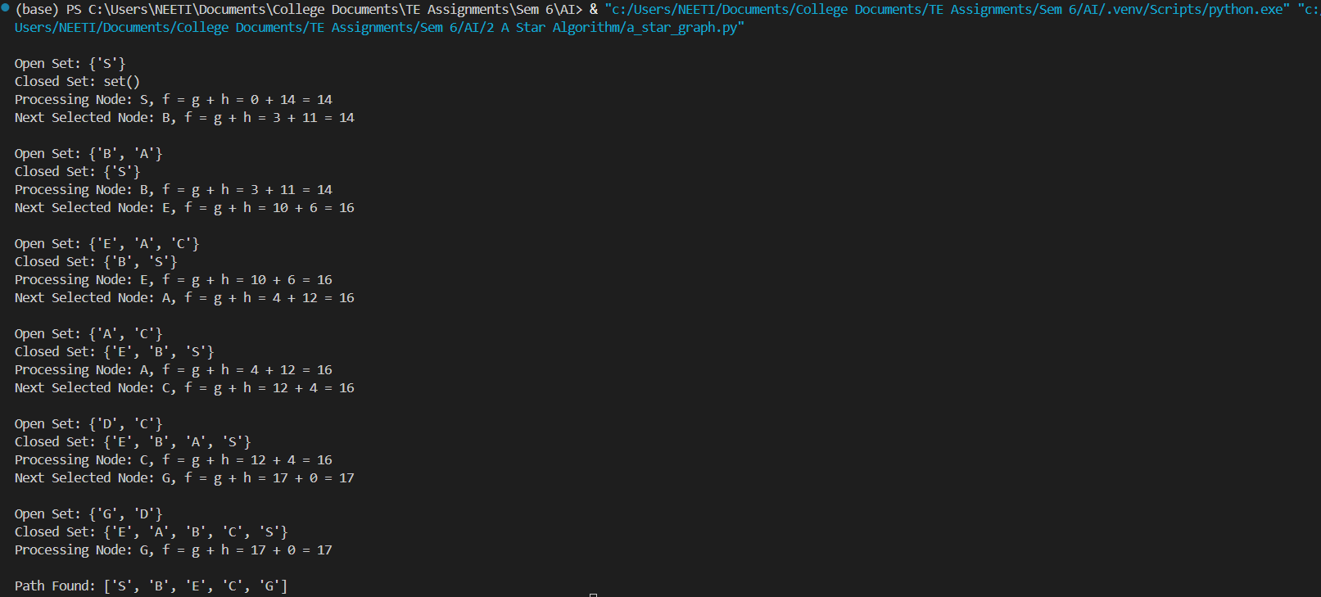

‘A’ ---> ‘E’

